1



AMERICAN INTERNATIONAL UNIVERSITY–BANGLADESH (AIUB)
Dept. of Computer Science
Faculty of Science and Technology
CSC2210: OBJECT ORIENTED PROGRAMMING 2
Fall 2024-2025
Section: A
Group No: 0912

Project Report On
Project Name: Pharmacy Management System
Supervised By
Md. Hasibul Hasan

Submitted By:
Name |  |  |  |  |  |  | ID
1. Fahim, Kahium Ahamed |  |  |  |  |  |  | 22-48593-3
2. Omi, Joydip Dey |  |  |  |  |  |  | 22-49473-3
3. Biswas, Utsa Kumar |  |  |  |  |  |  | 22-49803-3
Obtained Marks for CO2 and CO3 (Description given in the following page)
Assessment Criteria | Not Attended/ Incorrect (0) |  | Inadequate  (1-2) |  | Average  (3) | Good  (4) |  | Excellent  (5)
Evaluation Criteria (CO2) |  | Total = |  | Evaluation Criteria (CO3) |  |  |  | Total =
Requirement fulfillment |  |  |  | Organization of the application
Validation |  |  |  | Representation and Integration of Database
Verification |  |  |  | Graphical User Interface

2

 | CO2: Display and verify the mean of a real-life Project using the concepts of C# Graphical User Interface based environment with database integration to depict a desktop-based application.
 | Assessment Criteria |  | Not Attended/ Incorrect (0) | Inadequate  (1-2) |  |  | Average  (3) |  |  | Good  (4) |  |  | Excellent  (5)
 | Evaluation Criteria |  | Evaluation Definition
 | Requirement fulfillment |  | Fails to demonstrate any understanding of real-life scenariobased project development or functional requirement identification. There is no attempt to depict a project or identify functional requirements accurately. |  |  | Demonstrates limited understanding of real-life scenariobased project development and functional requirement identification. The project depicted lacks coherence or relevance to reallife scenarios, and functional requirements are inaccurately identified or insufficiently described. |  |  | Presents a basic depiction of a real-life scenariobased project and identifies some functional requirements. However, the project lacks depth or complexity, and some functional requirements may be vaguely defined or missing key details. |  |  | Effectively demonstrates a realistic scenariobased project and accurately identifies most functional requirements. The project is welldeveloped with appropriate complexity, and functional requirements are clearly articulated with relevant details. |  |  | Exhibits an exceptional  understanding of real-life scenariobased  project development and accurately identifies all functional requirements. The  project is meticulously developed with thorough attention to  detail, reflecting a comprehensive understanding of Object-Oriented Programming project development activities.
Validation |  | Fails to demonstrate any understanding or implementation of validation forms in their system. There is no attempt to deal with data validation, and validation requirements are completely ignored or incorrectly applied. |  |  | Demonstrates limited understanding of validation forms and data validation techniques. While some attempt may be made to implement  validation, it is incomplete or poorly executed, leading to inadequate handling of data validation. |  |  | Shows a basic understanding of validation forms and data validation techniques. They attempt to implement validation, but some aspects may be missing or incorrectly implemented, resulting in partial or inconsistent handling of data validation. |  |  | Effectively demonstrates the use of validation forms and implements data validation techniques. Validation is mostly accurate and comprehensive, ensuring the proper handling of data input and verification in the system. |  |  | Exhibits an exceptional understanding and  implementation of validation forms and data validation techniques. Validation is meticulously implemented with thorough attention to detail, ensuring robust data validation procedures and contributing to the overall reliability and integrity of the system.
Verification |  | Fails to demonstrate any attempt to verify the system data or functional requirements. There is no evidence of understanding or implementation |  |  | Demonstrates limited understanding of verification processes and data flow in the system. Verification attempts are incomplete or |  |  | Shows a basic understanding of verification processes and attempts to verify system data. However, verification efforts may be inconsistent or |  |  | Identifies and verifies system data, ensuring proper functional requirements are met. Verification efforts are mostly accurate and thorough, with attention to |  |  | Exhibits an exceptional understanding of verification processes and meticulously verifies system data. Verification efforts are comprehensive
3
CO3: Prepare and Explain a real life desktop based application synthesizing several component of C# along with development tools to adhere the given requirements.
Assessment Criteria | Not Attended/ Incorrect (0) | Inadequate  (1-2) | Average  (3) | Good  (4) | Excellent  (5)
Evaluation Criteria | Evaluation Definition

 | of verification processes, and data flow is not considered. | inaccurate, and there is insufficient consideration given to ensuring data integrity and functionality. | lack thoroughness, and there may be gaps in ensuring proper functional requirements and data flow. | ensuring data integrity and appropriate data flow within the system. | and precise, with a keen focus on ensuring all functional requirements are met and maintaining proper data flow throughout the system.

Organization of the application | Fails to identify any suitable real time application or requirements for project development  activities related to OOP. | Limited understanding about the project scopes and scenarios or identification of functional requirements. | Lacks depth or relevance to OOP project development activities and may contain inaccuracies. Real-life scenarios are mentioned, but the discussion lacks depth or clarity. | Consider and integrate the idea of several core aspects of the project along with relevance to real-life scenarios. Demonstrating a solid understanding of the application presentation. | Generalize and exhibits an exceptional understanding of project preparation according to a to real-life scenarios. Also contains proper and insightful identification of the system which is comprehensive and precise.
Representation and  Integration of Database | Fails to identify and present any understanding or implementation of database. Also failed to integrate the data with the project itself. | Limited understanding of the database concepts or their proper way of using in a real time project. While some attempt may be made to implement but it is incomplete or poorly executed, leading to inadequate design. | Lacks depth or relevance to database integration with the application. Shows a basic understanding but some aspects may be missing or incorrectly implemented, resulting in partial or inconsistency.  May lack proper normalization. | Integrate the database with the forms properly and implements it with proper validation which is mostly accurate and comprehensive, ensuring the proper handling of data input and verification along with general normalization. | Exhibits an exceptional understanding and implementation of database ensuring attention to detail, and robust data manipulation procedures and contributing to the overall clarity.
Graphical User Interface | Fails to present or prepare GUI based application interfaces. There is no evidence of creating or  integrating such  things according to their usefulness. | Limited understanding of graphical user interfaces. Lack of design knowledge. Very poor attempt to make such things which are currently obsolete or can’t be identified as coherent. | Shows a basic understanding of creating user interfaces. Most of them are interconnected but maybe some of them lack it.  However, most of it can be described as user friendly. | Effectively identifies and meet the consider the simplicity. Design related works are mostly accurate and taken proper attention to ensuring a userfriendly coherent system. | Exhibits an exceptional work design following a high standard of simple and elegant work. Several controls and mechanism has been organized in a preferred way according to the coherent usage .

Table of Contents: Page no.

- Chapter: 01 (Introduction)--------------------------------------------------------------------- 06
- Chapter: 02 (User Story)---------------------------------------------------------------------- 06-07
- Chapter: 03a (ER Diagram)------------------------------------------------------------------- 07-09
- Chapter: 03b (SQL Queries)------------------------------------------------------------------ 09-11
- Chapter: 04 (Screenshots)--------------------------------------------------------------------- 12-14

Pharmacy Management System
(A Windows-Forms Application)

Chapter 1: Introduction
The Pharmacy Management System (PMS) is a Windows Forms application designed to optimize retail store operations. It caters to administrators and managers, providing an intuitive interface for managing products, sales, and employee tasks. This report outlines the system's objectives, functionalities, and implementation details, emphasizing its ability to enhance efficiency and streamline workflows within a retail environment. Notably, our application comprises 6 separately designed forms, tailored to handle various aspects of shop management seamlessly.
Our Pharmacy Management System (PMS) offers a comprehensive solution for improving retail store operations. By automating tasks such as inventory management, manager management, and invoice generation, PMS ensures smooth workflows and minimizes the risk of errors. The system also supports efficient data handling and informed decision-making, ultimately enhancing operational efficiency, customer satisfaction, and overall business performance.

Chapter 2: User Story
- User Login:
- Feature: Secure login system for administrators and managers.
- Dashboard Management:
- Feature: Centralized admin dashboard for monitoring employees, products, and sales performance.
- Employee Management: (Admin)
- Feature: Add, update, or remove employee details for efficient workforce management.
- Product Management: (Admin)
- Feature: Manage product information, including adding, editing, and deleting products to maintain accurate inventory.

- Sales Analytics: (Admin)
- Feature: View sales data for business insights.
- Invoice Generation:
- Feature: Generate invoices for accurate billing and customer verification.
- Password Management: (Admin & Manager)
- Feature: Reset and update passwords securely to protect user accounts.
- Sell Product: (Admin & Manager)
- Feature: Employees Sales products and print invoices for customer transparency.
- Customer Receipts:
- Feature: Provide detailed invoices for customer transparency.

Chapter 3a: ER Diagram

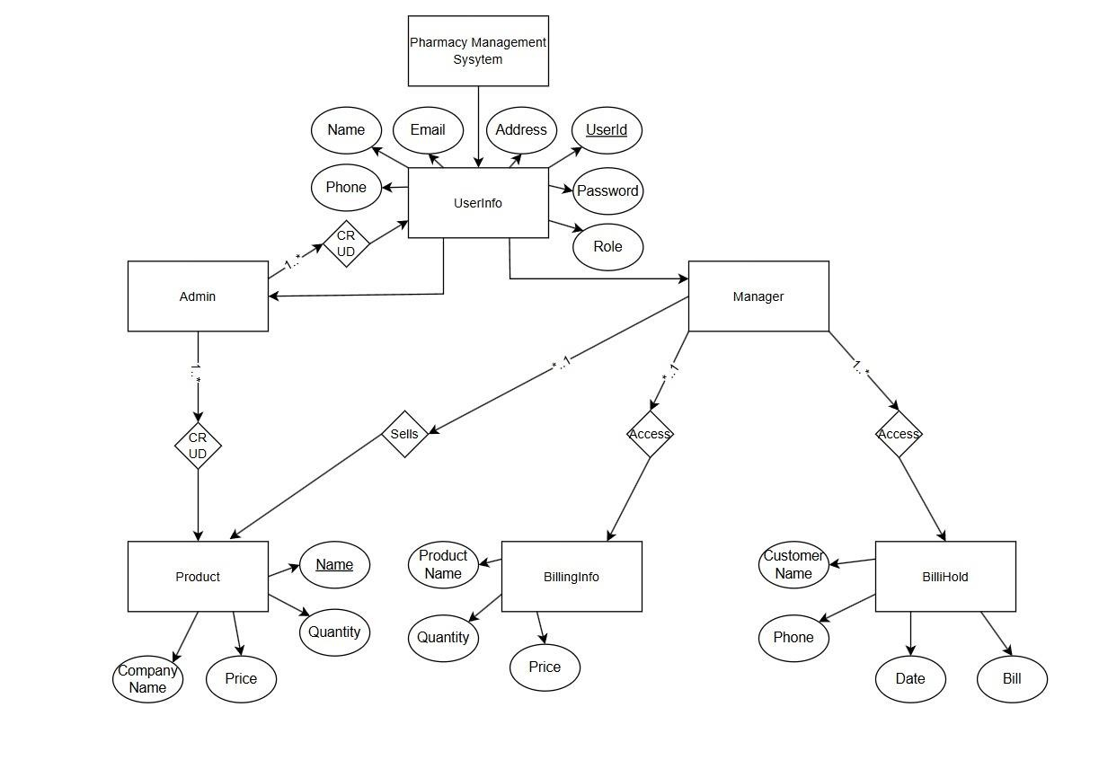
Normalization:

- UNF (Unnormalized Form) – Extract data from ERD:
We'll assume one large flat relation combining all information. Example attributes: (UserId, Name, Email, Phone, Address, Password, Role, ProductName, CompanyName, ProductQty,
ProductPrice, CustomerName, CustomerPhone, BillDate, BillAmount, ManagerId, AdminId)
- 1NF (First Normal Form) – Remove multivalued and repeating attributes Make sure every field contains only atomic values. Tables: a. UserInfo
  - UserId (PK)
  - Name
  - Email
  - Phone
  - Address
  - Password
  - Role (e.g., Admin/Manager)
- Admin
  - AdminId (PK, FK → UserInfo.UserId)
- Manager
  - ManagerId (PK, FK → UserInfo.UserId)
- Product
  - ProductId (PK)
  - ProductName
  - CompanyName
  - Quantity
  - Price
- BillingInfo
  - BillingId (PK)
  - ProductName (or FK → Product.ProductId)
  - Quantity
  - Price
- BillHold
  - BillHoldId (PK)
  - CustomerName
  - Phone
  - Date
  - Bill
3. 2NF (Second Normal Form) – Remove partial dependencies
a). UserInfo (UserId, Name, Email, Phone, Address, Password, Role)
- PK: UserId
- All non-key attributes depend fully on UserId → Already in 2NF.
b). Admin (AdminId [PK, FK → UserInfo.UserId]) • PK: AdminId
- Single attribute, fully dependent → Already in 2NF.
c). Manager (ManagerId [PK, FK → UserInfo.UserId])
- PK: ManagerId
- Single attribute, fully dependent → Already in 2NF.
d). Product (ProductId, ProductName, CompanyName, Quantity, Price)
- PK: ProductId
- All non-key attributes depend fully on ProductId → Already in 2NF.
e). BillingInfo (BillingId, ProductId [FK], Quantity, Price)
- PK: BillingId
- ProductId is foreign key.
- All non-key attributes depend fully on BillingId → Already in 2NF.
- Note: If Price is a copy of Product’s price and doesn't change per billing, this is a design issue (redundancy), but not a 2NF violation.

f). BillHold (BillHoldId, CustomerId [FK], Date, Bill)
- PK: BillHoldId
- All non-key attributes depend fully on BillHoldId → Already in 2NF. 4. 3NF (Third Normal Form) – Remove transitive dependencies

Customer
- CustomerId (PK)
- CustomerName
- Phone
Then update BillHold:
BillHold
- BillHoldId (PK)
- CustomerId (FK)
- Date
- Bill
Final Normalized Tables (3NF) o UserInfo (UserId, Name, Email, Phone, Address, Password, Role) o Admin (AdminId [PK, FK → UserInfo.UserId]) o Manager (ManagerId [PK, FK → UserInfo.UserId])
- Product (ProductId, ProductName, CompanyName, Quantity, Price)
- BillingInfo(BillingId, ProductId [FK], Quantity, Price) o BillHold(BillHoldId, CustomerId [FK], Date, Bill)

Chapter 3b: SQL Queries

SellControl.cs select* from Product; select* from Bilinginfo;
SELECT * FROM Product WHERE Name LIKE '%{name}%';
SELECT Quantity FROM Product WHERE Name = '{productName}'; SELECT * FROM Bilinginfo WHERE ProductName = '" + productName + "'; UPDATE Bilinginfo SET Quantity = " + quantity + @", Price = " + price + @" WHERE ProductName = '" + productName + "';

INSERT INTO Bilinginfo VALUES('" + productName + "', " + quantity + ", " + price + ");

SELECT ProductName, Quantity FROM Bilinginfo

UPDATE Product SET Quantity = Quantity - @Qty WHERE Name = @ProductName;

INSERT INTO Billhold (CustomerName, Phone, Date, Bill) VALUES ('{customerName}', '{phone}', '{date}', {totalPrice});
DELETE FROM BilingInfo;

SELECT Price FROM Product WHERE Name = '" + name + "';

SELECT SUM(Price) AS TotalPrice FROM Bilinginfo;

ProductHandle.cs
select* from Product;

UPDATE Product SET Name = '" + Name + @"', CompanyName = '" + CompanyName + @"', Quantity = " + Quantity+ @", Price = " + Price + @" WHERE Name = '" + name + @"';

DELETE FROM Product WHERE Name = '" + currentName + @"';
SELECT * FROM Product WHERE Name = '" + name + "';

INSERT INTO Product (Name, CompanyName, Quantity, Price) VALUES ('" + name + "', '" + company + "', " + quantity + ", " + price + ");

loginform.cs select * from UserInfo where UserId = '"+userid + "' and Password = '"+ password+"' ;

ProductHandle.cs
select* from Product

UPDATE Product SET Name = '" + Name+ @"', CompanyName = '" + CompanyName+ @"', Quantity = " + Quantity+ @", Price = " + Price) + @" WHERE Name = '" + name + @"';

DELETE FROM Product WHERE Name = '" + currentName + @"';
SELECT * FROM Product WHERE Name = '" + name + "';
INSERT INTO Product (Name, CompanyName, Quantity, Price) VALUES ('" + name + "', '"
+ company + "', " + quantity + ", " + price + ");";

UserHandle.cs select*from userinfo delete from userinfo where userid = '" + userid + "'; select * from userinfo where userid = '" + userid + "';

insert into userinfo (Name, Phone, Email, Adress, UserId, Password, Role) values('" + name
+ "', '" + phone + "', '" + email + "', '" + address + "', '" + userid + "', '" + password + "', '" + rl +
"');
select * from userinfo
select * from userinfo where userid = '" + userid + "';

update userinfo set Name = '" + name + @"', Phone = '" +phone + @"',
Email = '" + email + @"',
Adress = '" + address + @"', Password = '" + password + @"', role = '" + role + @"'
where userid = '" + userid + "';

SELECT * FROM UserInfo WHERE Name = '" + name+ "';

Sellinginfo.cs

select* from Billhold

Chapter 4: Screenshots
